- Define Key Management. Explain any four key management processes mentioned in the key lifecycle
Key management is perhaps best described as the secure administration of cryptographic keys. Key management involves a wide range of quite disparate processes, all of which must come together coherently if cryptographic keys are to be securely managed. The important thing to remember is that cryptographic keys are just special pieces of data. Key management thus involves most of the diverse processes associated with information security.
Key generation concerns the creation of keys.
Key establishment is the process of making sure that keys reach the end points where they will be used. This is arguably the most difficult phase of the key lifecycle to implement.
Key storage deals with the safekeeping of keys. It may also be important to conduct key backup so that keys can be recovered in the event of loss of a key and, ultimately, key archival.
Key usage is about how keys are used. As part of this discussion we will consider key change. We will also look at how a key’s life ends in key destruction.
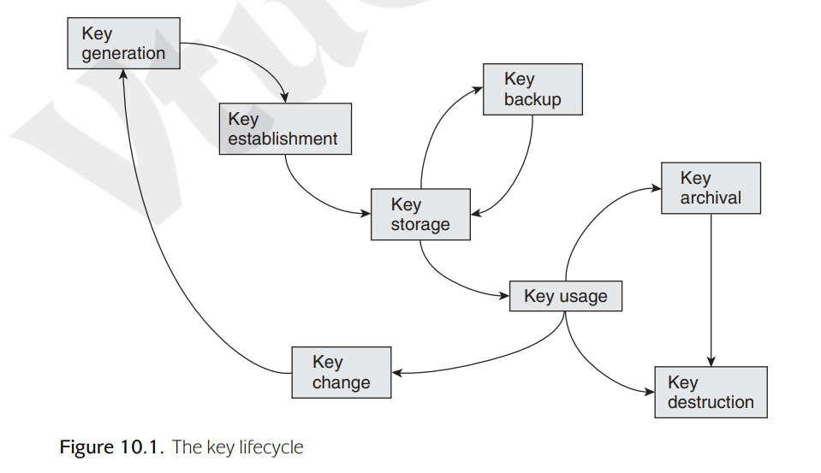
- Describe the concept of “Key Lifetime” and explain why cryptographic keys should have a limited lifetime with suitable examples.
The issue of key length is closely linked to the intended lifetime of a cryptographic key. By this we mean that the key can only be used for a specified period of time, during which it is regarded as being live. Once that lifetime has been exceeded, the key is regarded as expired and should no longer be used. At this point it may need to be archived or perhaps destroyed.
There are many reasons why cryptographic keys have finite lifetimes. These include:
Mitigation against key compromise: Having a finite lifetime prevents keys being used beyond a time within which they might reasonably be expected to be compromised, for example by an exhaustive key search or compromise of the storage medium.
Mitigation against key management failures: Finite key lifetimes help to mitigate against failures in key management. For example, forcing an annual key change will guarantee that personnel who leave an organisation during the year, but for some reason retain keys, do not have access to valid keys the following year.
Mitigation against future attacks: Finite key lifetimes help to mitigate against future advances in the attack environment. For this reason, keys are normally set to expire well before current knowledge suggests that they need to.
Enforcement of management cycles: Finite lifetimes enforce a key change process, which might be convenient for management cycles. For example, if keys provide access to electronic resources that are paid for on an annual subscription basis, then having a one-year key lifetime allows access to keys to be directly linked to subscriptions to the service.
Flexibility: Finite key lifetimes introduce an additional ‘variable’ which can be adjusted to suit application requirements. For example, a relatively short key (which is relatively inexpensive to generate, distribute and store) could be adopted under the pretext that the key lifetime is also suitably short.
Limitation of key exposure: At least in theory, some information relating to a key is ‘leaked’ to an attacker every time the attacker sees a cryptographic value computed using that key. This is because the result of every cryptographic computation provides the attacker with information that they did not have before they saw the ciphertext. We refer to this as key exposure. However, this information is normally of little (often no) use to an attacker if the cryptographic algorithm is strong, hence in many applications key exposure is not a significant issue.
- Compare and analyze the difference between Key Translation and Key Despatch approaches used in symmetric key distribution through a Key Centre. Mention advantages and disadvantages of each
There are two key distribution appoaches to acquiring shared keys from a KC. We illustrate these using a very simple scenario. In each case we assume that Alice wishes to establish a shared data key K with Bob. We will also assume that both Alice and Bob have respectively established master keys KAC and KBC with the KC, and that a simple two-level key hierarchy is being employed. The two approaches are:
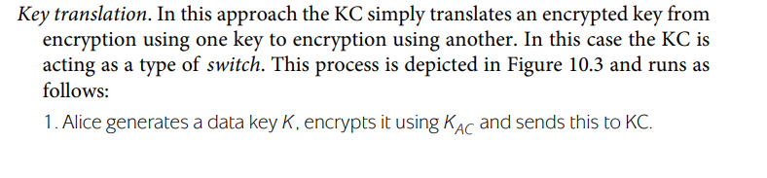
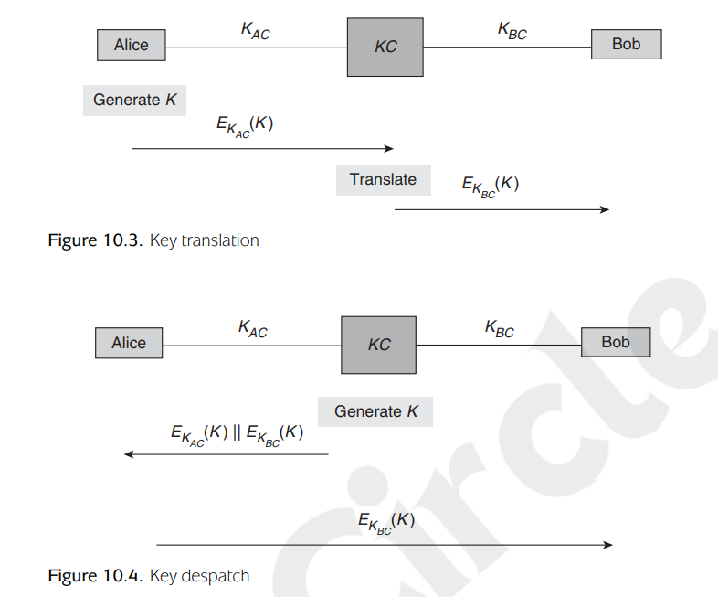
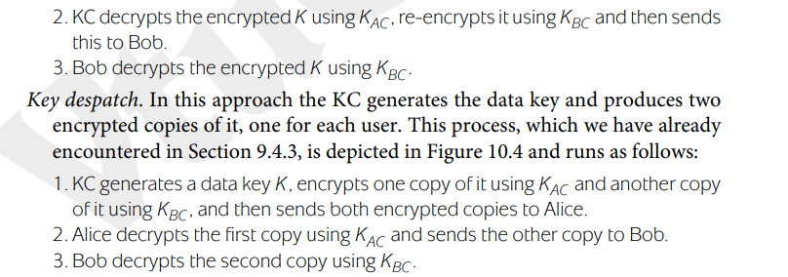
The only real difference between these two key distribution approaches is who generates the data key. Both approaches are used in practice.
An alternative way of deploying key hierarchies for networks of many users is to use public-key cryptography and have a master public-key pair. We can think of hybrid encryption as a two-level key hierarchy where the public key plays the role of a master key, which is then used to encrypt data keys. However, it is important to recognise that this approach comes with its own issues and does not do away with the need for a trusted third party of some sort.
5. Define Transport Layer Security (TLS). List and briefly explain any five components or protocols of the TLS protocol stack
TLS is a general purpose service implemented as a set of protocols that rely on TCP. At this level, there are two implementation choices. For full generality, TLS could be provided as part of the underlying protocol suite and therefore be transparent to applications.
TLS is designed to make use of TCP to provide a reliable end-to-end secure service. TLS is not a single protocol but rather two layers of protocols
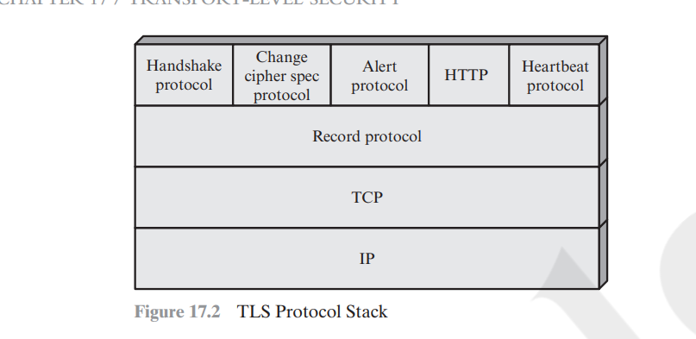
The TLS Record Protocol provides basic security services to various higher layer protocols. In particular, the Hypertext Transfer Protocol (HTTP), which provides the transfer service for Web client/server interaction, can operate on top of TLS. Three higher-layer protocols are defined as part of TLS: the Handshake Protocol; the Change Cipher Spec Protocol; and the Alert Protocol. These TLSspecific protocols are used in the management of TLS exchanges and are examined later in this section. A fourth protocol, the Heartbeat Protocol, is defined in a separate RFC and is also discussed subsequently in this section.
Two important TLS concepts are the TLS session and the TLS connection, which are defined in the specification as follows:
■ Connection: A connection is a transport (in the OSI layering model definition) that provides a suitable type of service. For TLS, such connections are peer-topeer relationships. The connections are transient. Every connection is associated with one session.
■ Session: A TLS session is an association between a client and a server. Sessions are created by the Handshake Protocol. Sessions define a set of cryptographic security parameters, which can be shared among multiple connections. Sessions are used to avoid the expensive negotiation of new security parameters for each connection.
Between any pair of parties (applications such as HTTP on client and server), there may be multiple secure connections. In theory, there may also be multiple simultaneous sessions between parties, but this feature is not used in practice. There are a number of states associated with each session. Once a session is established, there is a current operating state for both read and write (i.e., receive and send). In addition, during the Handshake Protocol, pending read and write states are created. Upon successful conclusion of the Handshake Protocol, the pending states become the current states

